10 Linux Comments
- uptime
- Description: Displays system uptime, logged-in users, and system load averages.
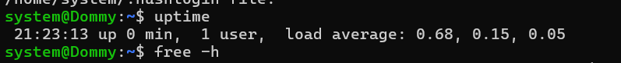
- free
- Description: Displays memory usage, including total, used, and available RAM.
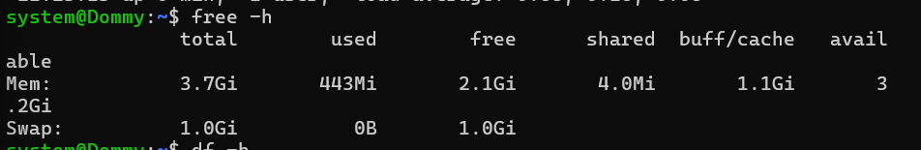
- df
- Description: Displays disk space usage for mounted filesystems in a human-readable format.
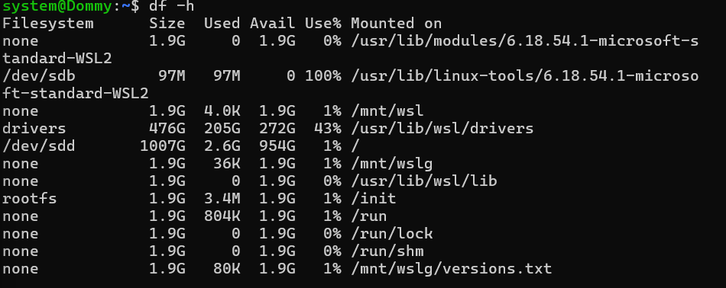
- du
- Description: Displays the disk space occupied by a specified directory
- hostname
- Description: Displays the hostname of the current Linux system.
- who
- Description: Displays users currently logged into the system.
- id
- Description: Displays the current user's UID, GID, and group memberships.
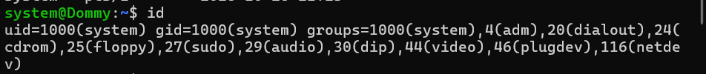
- printenv
- Description: Displays environment variables configured for the current shell session.
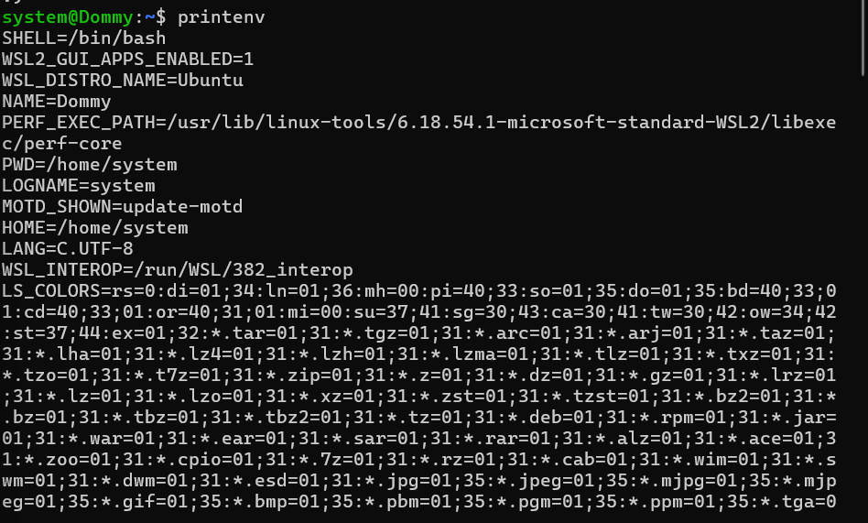
- lsblk
- Description: Lists block devices, including disks and partitions, with their sizes and mount points.
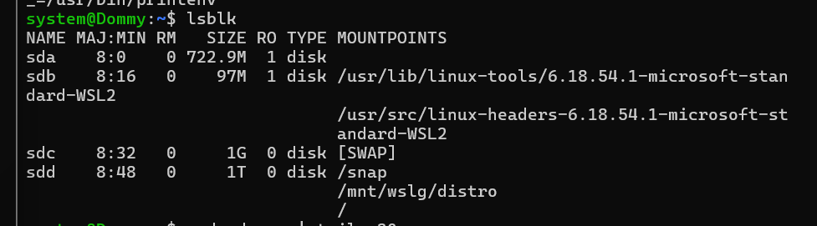
- dmesg
- Description: Displays kernel messages to help troubleshoot hardware and system-related issues.
